Global Fuel Prices and Taxation Trends: Project Report
Oct 28, 2026 · @Vidhi Sharma

1. INTRODUCTION

1.1 Project Overview
Fuel prices differ greatly from one country to another, and so do the taxes and subsidies behind them. This project analyses weekly fuel price and tax data for 84 countries from January 2020 to April 2026, a total of 27,468 records. The data covers petrol, diesel and LPG prices in US dollars per litre, the Brent crude oil price, the tax percentage, and each country's region, income level and subsidy level.
The analysis is built in Tableau and presented as one interactive dashboard of seven linked charts: a world map of average petrol prices, the top 10 most expensive countries, the price trend over time, a comparison of petrol with Brent crude, average tax share by region, and average prices by income level and by subsidy level.

1.2 Purpose
The purpose of the project is to turn a large weekly dataset into a clear, visual explanation of how fuel is priced and taxed around the world. The dashboard is designed to:
- show which countries pay the most and the least for petrol;
- show how income level and subsidies relate to the pump price;
- show how much tax is included in the fuel price in each region;
- show how petrol and diesel prices have moved with crude oil since 2020.

2. IDEATION PHASE

2.1 Problem Statement
The raw dataset is a CSV file with more than 27,000 weekly rows. It is hard to read in a spreadsheet, and the patterns that matter (price gaps between countries, the effect of subsidies, the link to crude oil) cannot be seen without summarising and visualising the data.
I am | A student or analyst who compares fuel costs across countries
I am trying to | Understand why fuel prices differ and how they change over time
But | The data is a long weekly table, with noisy tax values, that I cannot read at a glance
Because | There is no single view that combines prices, tax, income, subsidy and crude oil
Which makes me feel | Unsure which factors really drive the pump price

2.2 Empathy Map Canvas
The empathy map describes the main user of the dashboard: a student, analyst or policy reader who wants quick answers about fuel prices.
Says | Thinks
"Which countries pay the most for petrol?" "Is it tax or subsidy that makes the difference?" "Do prices follow oil?" | The data is too big to scan by hand. A picture will show the pattern faster than a table. The averages must be trustworthy.
Does | Feels
Filters the data by region and income level. Compares countries and years. Looks for the highest and lowest values. | Confused by weekly ups and downs. Confident when the charts agree with the numbers. Interested when clicking a chart updates the rest.

Pains | Gains
Large raw data, noisy weekly tax values, no single overview | One dashboard, clear comparisons, filters and click-to-filter, headline numbers on top

2.3 Brainstorming
Several ideas were considered for the dashboard. Each was rated on value to the user and effort to build, and the ideas with high value and reasonable effort were selected.
Idea | Value | Effort | Decision
World map of average petrol price | High | Low | Selected
Top 10 most expensive countries | High | Low | Selected
Price trend for petrol and diesel | High | Low | Selected
Petrol against Brent crude (dual axis) | High | Medium | Selected
Average tax share by region | High | Low | Selected
Prices by income level and subsidy level | High | Low | Selected
Forecasting future prices | Medium | High | Future scope
Prices in local currency | Low | High | Not selected
Live price feed | Medium | High | Future scope

3. REQUIREMENT ANALYSIS

3.1 Customer Journey map
The journey follows a user from first opening the dashboard to sharing what they learned.
Stage | Goal | Action | Experience | Opportunity
Discover | Know what the dashboard covers | Reads the title and the headline numbers | Clear scope: 84 countries, 2020 to 2026 | Short KPI row at the top
Explore | Find the most and least expensive countries | Looks at the map and the top 10 chart | Patterns are visible at once | Tooltips with exact values
Analyze | Understand why prices differ | Compares income, subsidy and tax charts | Subsidy stands out as the main driver | Filters by region, income and subsidy
Decide | Draw a conclusion | Checks the trend and the Brent comparison | Petrol follows crude oil closely | Notes that explain the data limits
Share | Present the findings | Exports or publishes the dashboard | Easy to show in a meeting | Publish to Tableau Public

3.2 Solution Requirement
Functional requirements
ID | Requirement
FR-1 | Load the weekly fuel price CSV into Tableau and recognise Country as a geographic field
FR-2 | Show average petrol price by country on a world map
FR-3 | Rank the 10 most expensive countries
FR-4 | Show petrol and diesel price trends by quarter
FR-5 | Compare petrol price with Brent crude on a dual-axis chart
FR-6 | Show average tax share by region and average price by income and subsidy level
FR-7 | Provide filters (region, income, subsidy) and click-to-filter between charts
Non-functional requirements
ID | Requirement
NFR-1 | Accuracy: every chart must use averages, and the values must match an independent calculation
NFR-2 | Readability: consistent colours, titles and labels across all charts
NFR-3 | Usability: a beginner can use the filters without instructions
NFR-4 | Honesty: data limits are stated on the dashboard and in the report

3.3 Data Flow Diagram
Data moves from the CSV file through a data check and the Tableau data source, is aggregated into averages, feeds the seven worksheets, and is combined into the dashboard that the user views.
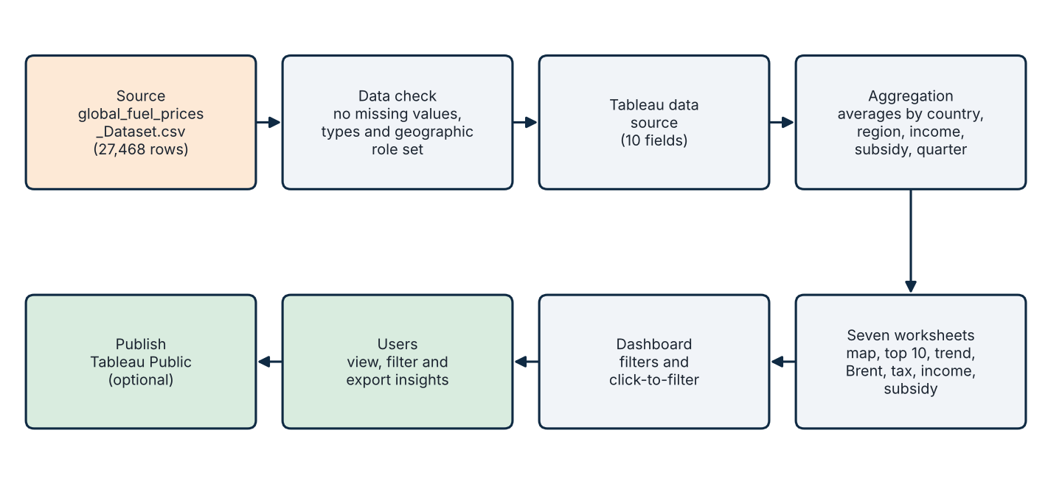

3.4 Technology Stack
Layer | Tool | Use in this project
Data | CSV file (global_fuel_prices_Dataset.csv) | Source of 27,468 weekly records
Visual analytics | Tableau (Desktop or Public) | Worksheets, dashboard, filters and actions
Map tiles | Mapbox and OpenStreetMap (inside Tableau) | Base map for the country map
Verification | Python with pandas | Independent check of the averages shown in Tableau
Reporting | PowerPoint and PDF | Presentation deck and this report

4. PROJECT DESIGN

4.1 Problem Solution Fit
Problem | Solution in the dashboard | Fit
Large weekly table is hard to read | Averages shown in seven focused charts | Patterns visible at a glance
Cannot see which countries pay most | World map and top 10 chart | Highest and lowest countries found in seconds
Unclear what drives price | Income and subsidy charts side by side | Subsidy shown as the stronger factor
Tax values vary from week to week | Averages by region | Stable, comparable figures
Link to crude oil is unclear | Petrol against Brent on one chart | Close movement is obvious

4.2 Proposed Solution
The proposed solution is a single interactive Tableau dashboard. A title and a row of headline numbers sit at the top. The world map and the top 10 chart show where fuel is expensive. The trend, Brent and tax charts show change over time and tax by region, and the income and subsidy charts explain differences between countries. Filters for region, income level and subsidy level are on the right, and clicking any chart filters the others.
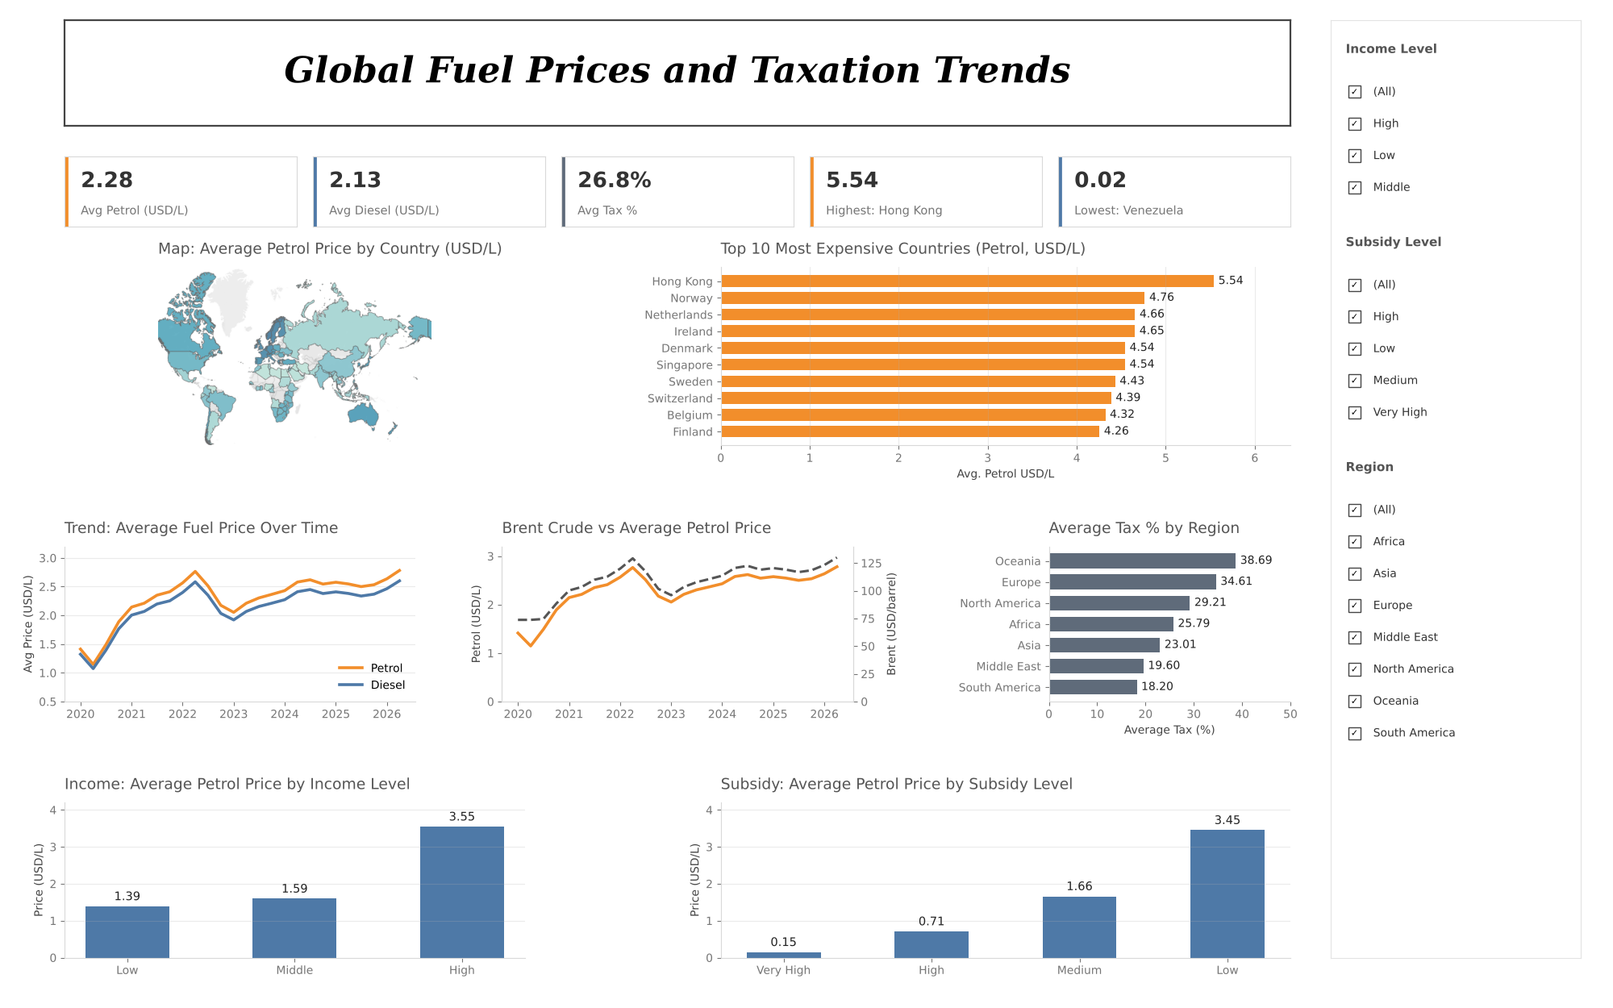

4.3 Solution Architecture
The solution has four layers. The data layer holds the CSV file. The preparation layer defines data types and the geographic role in Tableau. The analytics layer computes averages and builds the seven worksheets. The presentation layer combines the worksheets into the dashboard for the user.
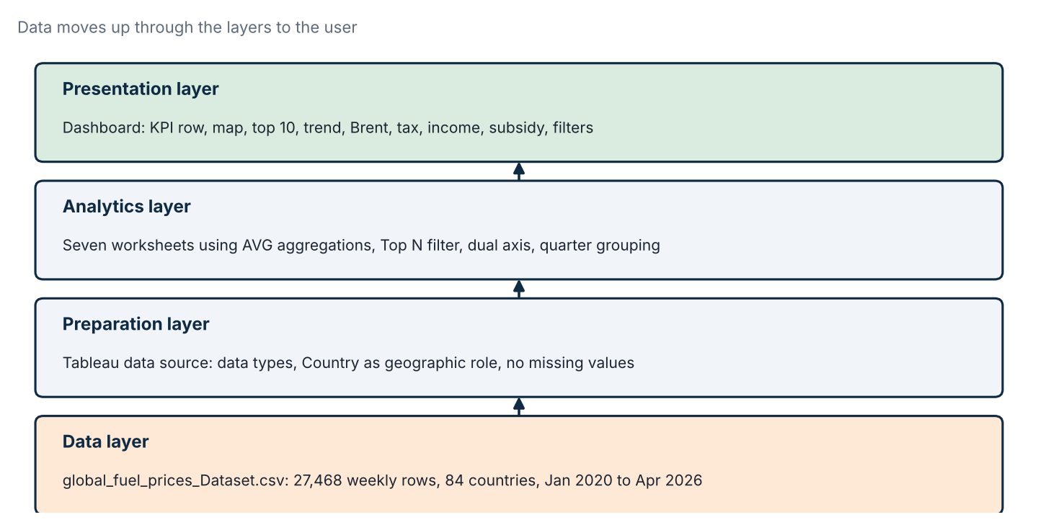

5. PROJECT PLANNING & SCHEDULING

5.1 Project Planning
Phase | Activities | Date | Status
1. Understand the data | Read the dataset, check columns and missing values, define the questions, plan the sheets | 26 Oct 2026 | Completed
2. Build worksheets | Create the seven sheets, correct SUM to AVG, set quarterly dates, set the map as filled countries | 27 Oct 2026 | Completed
3. Test and correct | Check values against an independent calculation, remove leftover filters, fix axes and labels | 27 to 28 Oct 2026 | Completed
4. Presentation and report | Prepare the PowerPoint deck and this report | 28 Oct 2026 | Completed
5. Final dashboard polish | Align the dashboard layout, match colours and fonts | 28 Oct 2026 | In progress

6. FUNCTIONAL AND PERFORMANCE TESTING

6.1 Performance Testing
Accuracy was treated as the main performance measure for this project. Values shown in Tableau were compared with an independent calculation in Python (pandas) on the same CSV file, and every checked value matched.
Test | Expected result | Result
Data load | 27,468 rows, 84 countries, no missing values | Passed
Average petrol price, Spain (map tooltip) | 3.878 USD per litre | Passed (3.878)
Top 10 countries | Hong Kong 5.54, Norway 4.76, Netherlands 4.66 at the top | Passed
Income level averages | Low 1.39, Middle 1.59, High 3.55 | Passed
Subsidy level averages | Very High 0.15, High 0.71, Medium 1.66, Low 3.45 | Passed
Regional tax averages | Oceania 38.7 down to South America 18.2 | Passed
Click-to-filter and filters | Selecting a country or a level updates the other charts | Passed
Testing also found defects during development. Each was corrected.
Defect found | Cause | Correction
Brent crude axis showed 800K and diesel reached 3,000 | Measures were summed over all weeks and countries | Changed the aggregation to Average
Trend chart showed only Q1 to Q4 | Quarter was used as a date part, merging all years | Used continuous quarterly dates
Map displayed as a list of countries | Country was on Rows, not latitude and longitude | Used generated latitude and longitude with Country on Detail
Charts went blank after clicking the dashboard | Leftover Action filters on the sheets | Removed the Action filters
Petrol and diesel drawn as two panels | Two separate measures on Rows | Merged into one dual-axis chart with a synchronised axis
Axis titles swapped on the Brent chart | Titles typed on the wrong axes | Left axis named for petrol, right axis for Brent
Response times were not formally measured. The dataset is about 1.8 MB, and no slow response was reported during development.

7. RESULTS

7.1 Output Screenshots
Figures 4 to 7 are screenshots taken from the Tableau workbook. Figures 8 and 9 were rebuilt from the same dataset to show the final quarterly view. You can replace any picture with your own final Tableau screenshot.
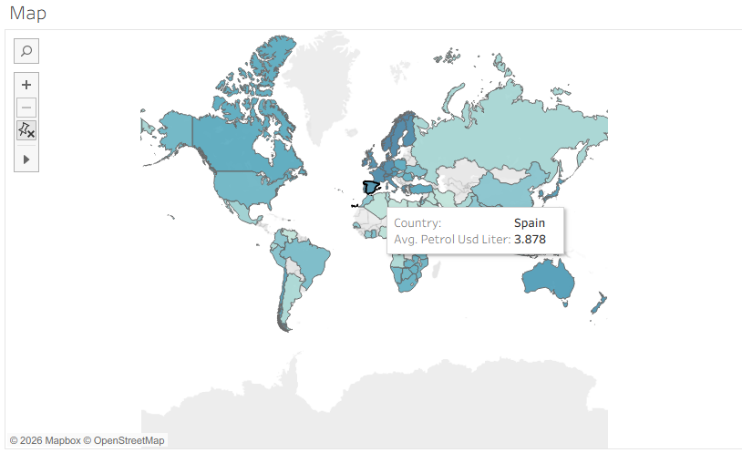
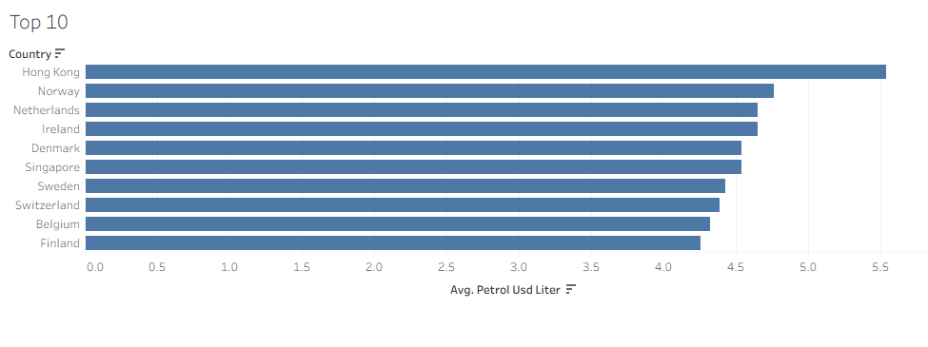
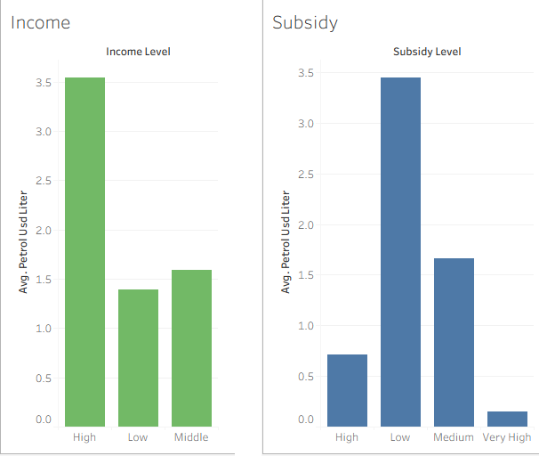
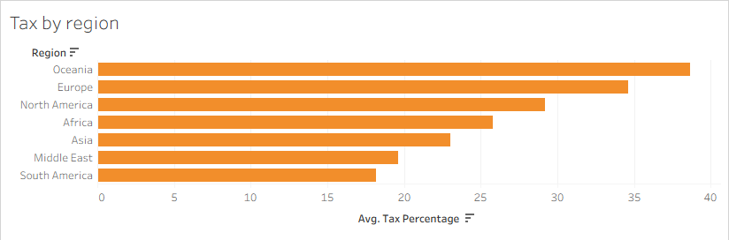
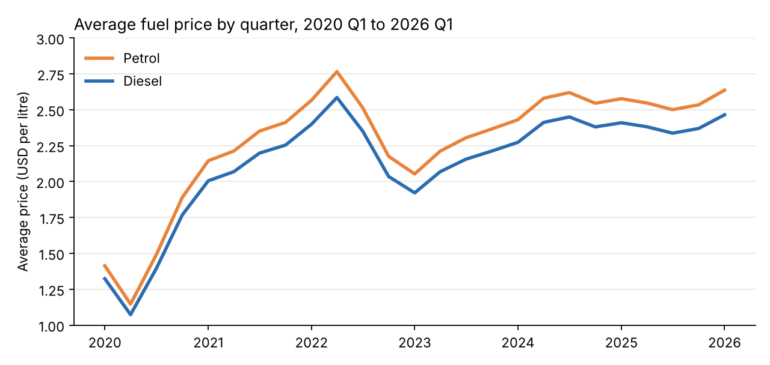
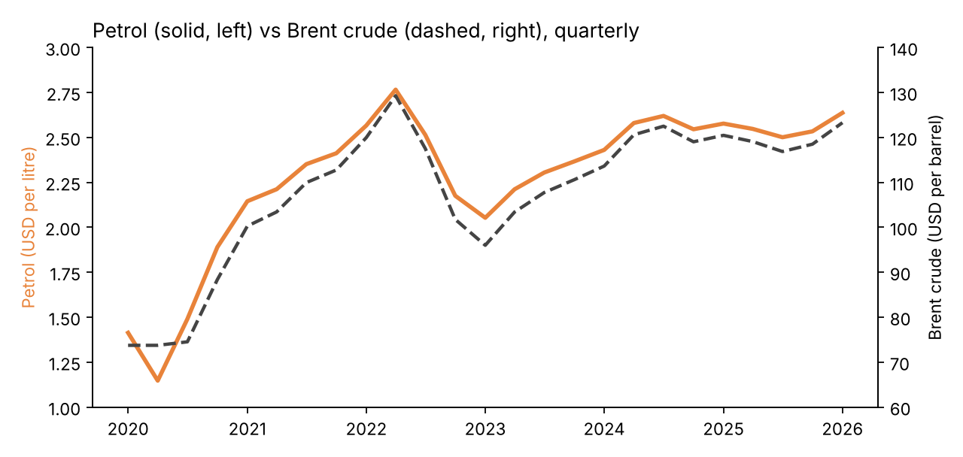
Key results
Finding | Result
Most and least expensive country (average petrol) | Hong Kong 5.54 and Venezuela 0.02 USD per litre
Effect of subsidy | Very High subsidy 0.15 against Low subsidy 3.45 USD per litre
Effect of income | Low income 1.39 against High income 3.55 USD per litre
Tax share by region | Oceania 38.7 percent, South America 18.2 percent
Petrol and Brent crude | Correlation of 0.99 on quarterly averages (2020 Q1 to 2026 Q1)
Highest quarterly petrol average | 2.77 USD per litre in 2022 Q2

8. ADVANTAGES & DISADVANTAGES

Advantages
- One dashboard answers four clear questions about fuel prices.
- Interactive filters and click-to-filter let users explore without extra tools.
- All figures use averages and were checked against an independent calculation.
- The dashboard can be shared online through Tableau Public.

Disadvantages
- Weekly tax percentages vary widely for one country, so only averages can be trusted.
- The Brent crude value is the same for every country in a given week, so it shows the trend only.
- Regional and income averages hide differences between individual countries.
- The April 2026 data covers only one week of the second quarter, so the trend charts stop at Q1 2026.

9. CONCLUSION
This project turned 27,468 weekly records into an interactive Tableau dashboard that explains global fuel prices. The results show that subsidy level separates prices more sharply than income level (0.15 against 3.45 USD per litre for Very High and Low subsidy), that Oceania and Europe carry the highest tax shares, and that petrol prices follow Brent crude very closely (correlation 0.99). Hong Kong is the most expensive country and Venezuela the cheapest. Checking the values against an independent calculation showed that the dashboard is accurate, and the defects found during testing were corrected. The limits of the data are stated so that the findings are not over-read.

10. FUTURE SCOPE
- Add GDP per capita to test how income relates to tax and price.
- Add forecasting to estimate future petrol and diesel prices.
- Show tax in US dollars per litre as well as a percentage.
- Connect a live price source so the dashboard updates automatically.
- Add LPG price views, which are in the data but not yet charted.

11. APPENDIX

Source Code (if any)
The dashboard was built in Tableau without custom code. Python (pandas) was used only to check the averages shown in Tableau, for example:
import pandas as pd
df = pd.read_csv("global_fuel_prices_Dataset.csv")
print(df[df.country == "Spain"].petrol_usd_liter.mean())
print(df.groupby("income_level").petrol_usd_liter.mean())
print(df.groupby("subsidy_level").petrol_usd_liter.mean())
print(df.groupby("region").tax_percentage.mean())

Dataset Link
Dataset file: global_fuel_prices_Dataset.csv (27,468 rows, 10 columns, 6 January 2020 to 6 April 2026).
Online link: ____________________

GitHub & Project Demo Link
GitHub: ____________________
Tableau Public dashboard: ____________________

Contact
Vidhi Sharma, en25cs3011043@medicaps.ac.in

